**MIS 6873 Final Exam**

**This exam is to be submitted through Bb by Wed, Dec 5 at 11:59 PM.**

The value of this exam is 112 points which is a 12-point curve. However, the highest grade you can make for this part is 100. It will then be averaged with the multiple-choice exam for your Final Exam grade. By entering you name below, you acknowledge that you have completed all items on this final exam without any help from any other person.

**Name: _____________William Eddy_______**

**Part 1: Normalization**

1. Using the following invoice, convert the data into 3RD Normal Form in Sentence Structure. Be sure to use your conventions (caps, underline, (f), etc.) (7 pts)

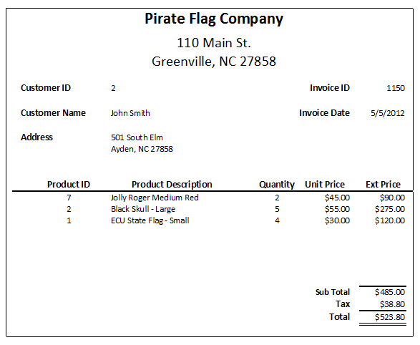

Solution:

Database Name: PIRATE_FLAG_CORP

CUSTOMER: (*CustomerID*, LastName, FirstName, City, State, StreetAddress)

CUSTOMER_PRODUCT: (InvoiceID, *ProductID*, *CustomerID*, InvoiceDate, Quantity, ExtPrice)

PRODUCT: (*ProductID*, ProductDescription, UnitPrice)

1. Which normal form violation is the following table? ___1st____(3)

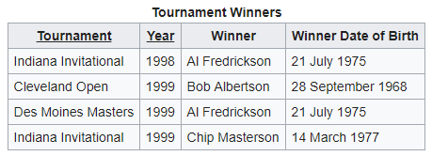

1. 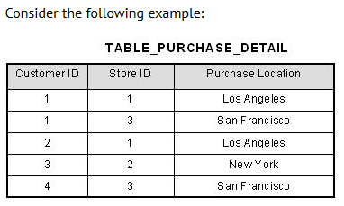(3)

Primary Key = (Customer ID, Store ID)

Normal Form Violated in the table above: ______2nd_________

1. Consider the following sentence structure. (3)

CustomerID, CustLName, CustFName, CustDoB, CustPhone, CustCity

What normal form violation is the structure above? ___None, but database should be identified and CustomerID Should be underlined for correct sentence structure._____

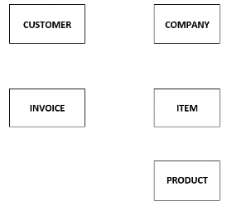

**Part 2: Data Model**

1. Create a Data Model ERD in Visio showing only the relationships (6)

Solution (Copy/paste from Visio):

**Are PRODUCT and ITEM different? I assumed they are the same in my diagram.**

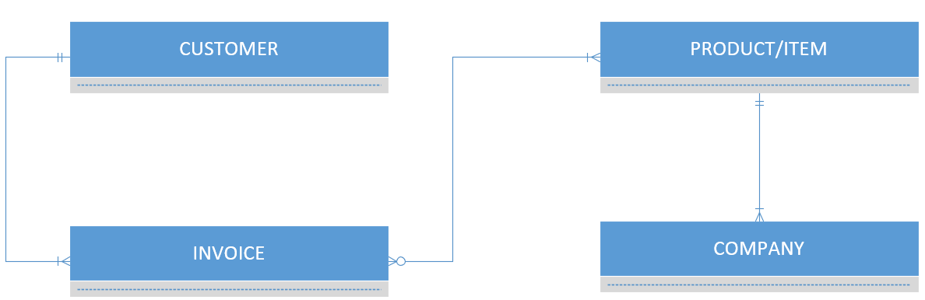

**Part 3: Database Design**

1. Create a database design of the following image in Visio showing all data for each attribute (name, PK, FK, data type, null, surrogate, etc.) You will need to complete the correct relationships. (12)

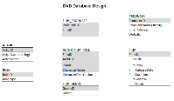

Solution (copy/paste from Visio)

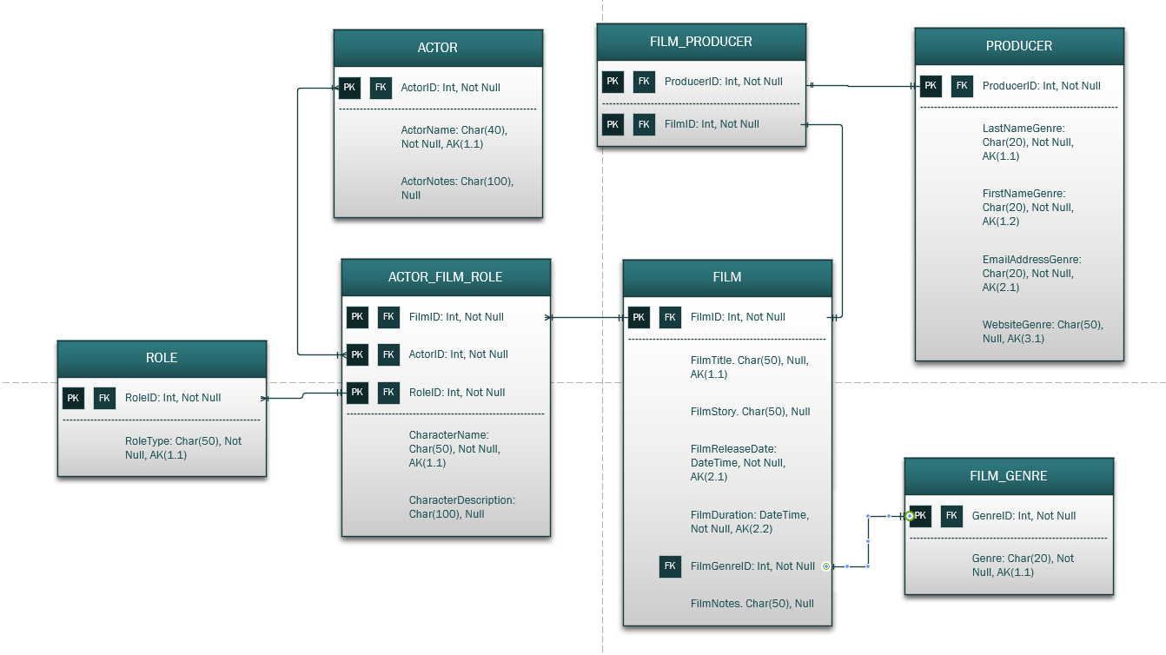

1. Create a database design on the next page from the following data model description using the template. Please note that you should create them in the template in the **EXACT** order listed here! (12)

NOTE: Be sure to include the relationship information:

Table: CLIENT

The Client table will include the following fields: *ClientID* which is an integer data type, it is a primary key not null and a surrogate key with the numbering starting at 1 and incrementing by 1; *FirstName* which is a character data type with 15 characters, and is not null; *LastName* which is a character data type with 15 characters, and is not null; *Phone* which is a character data type with 12 characters and not null; *Gender* which is a character data type with 1 character, and is not null; *Email* which is a character data type with 100 characters, and is not null.

Table: INVOICE

The invoice table will include the following fields: *InvoiceNumber* which is an integer data type, it is a primary key, and is not null; *ClientID* which is an integer data type, it is a foreign key not null ; *SaleDate* which is a datetime data type and is not null; *TotalAmount* which is a numeric data type with 2 decimals and is null.

Table: INVOICE_ITEM

The invoiceitem table will include the following fields: *InvoiceNumber* which is an integer data type, it is both a primary key and a foreign key and is not null; *ItemNumber* which is an integer data type and a primary key, and is not null; *Item* which is a character data type with 50 characters and is not null; *Quantity* which is an integer and is not null and has a default value of 1; *UnitPrice* is a numeric data type with 2 decimals and is null.

|  |  |  |  |  |
| --- | --- | --- | --- | --- |
| Table: CLIENT |  |  |  |  |
| **Column Name** | **Type** | **Key** | **NULL Status** | **Remarks** |
| ClientID | Int | PK, FK | NOT NULL | Surrogate key(1.1) |
| FirstName | Char(15) |  | NOT NULL |  |
| LastName | Char(15) |  | NOT NULL |  |
| Phone | Char(12) |  | NOT NULL |  |
| Gender | Char(1) |  | NOT NULL |  |
| Email | Char(100) |  | NOT NULL |  |
|  |  |  |  |  |
| Table: INVOICE |  |  |  |  |
| **Column Name** | **Type** | **Key** | **NULL Status** | **Remarks** |
| InvoiceNumber | Int | PK | NOT NULL |  |
| ClientID | Int | FK | NOT NULL |  |
| SaleDate | DateTime |  | NOT NULL |  |
| TotalAmount | Numeric (8.2) |  | NULL |  |
|  |  |  |  |  |
| Table: INVOICE_ITEM |  |  |  |  |
| **Column Name** | **Type** | **Key** | **NULL Status** | **Remarks** |
| InvoiceNumber | Int | PK, FK | NOT NULL |  |
| ItemNumber | Int | PK | NOT NULL |  |
| Item | Char (50) |  | NOT NULL |  |
| Quantity | Int |  | NOT NULL | Default value 1 |
| UnitPrice | Numeric (8,2) |  | NULL |  |

|  |  |  |  |  |
| --- | --- | --- | --- | --- |
| **Relationship** | | **Cardinality** | | |
| **Parent** | **Child** | **Type** | **MAX** | **MIN** |
| CLIENT | INVOICE | ID dep | 1:N | O-M |
| INVOICE | INVOICE_ITEM | ID dep | 1:N | O-M |

**Part 4: Data Manipulation**

1. Execute the *Greenville Lumber Create Tables* file that is supplied. (2) Already done!
2. Execute the *Greenville Lumber Insert Data* file that is supplied. (2) Already done!

**Complete each problem below copy/pasting both the code and solution:**

**Each of the following is worth 4 Points:**

1. Change the name of vendor #8 from “none” to “In House Build” (4)

Code:



Solution:



1. List each vendor showing their name, the name of the contact, and any notes. Sort by the vendor. (4)

Code:



Solution:

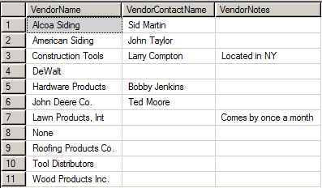

1. List all product items and their descriptions where “wood” is used within the description. (4)

Code:



Solution:

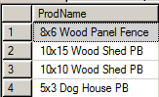

1. List every customer (last name then first name strung together) from North Carolina and the city they are from who has purchased any product. Name the new field SaleCustomer and do not show duplicate names and sort by their last name. Use a subquery. (4)

Code:

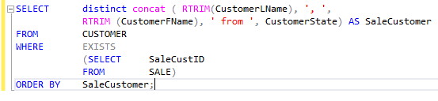

Solution:

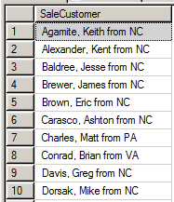

1. List all products that have a unit price of over $500 or under $200. Include the product name and unit price and sort by price in descending order. (4)

Code:

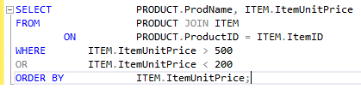

Solution:

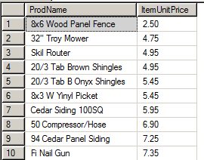

1. What is the potential profit if all items in the Tools and Outdoor inventory were sold? (4)

Code:



Solution:



1. Show the total inventory value of all product items by category and sort by inventory value. (4)

Code:

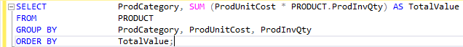

Solution:

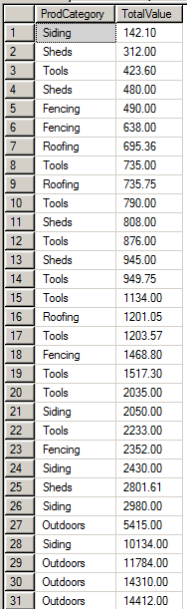

Not quite right, but not sure how to fix it!

**Each of the following is worth 5 Points:**

1. List all the vendor and all the different tools they supply, and then sort by vendor name and then by product name. (5)

Code:

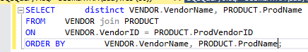

Solution:

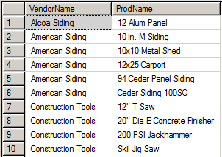

1. List every product item that was purchased in the tools category during 2018 thus far. Include the product name and the sale date. (5)

Code:

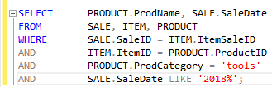

Solution:

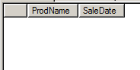

1. List all customers who have purchased fencing items. Include the customer’s name (first then last strung together) naming the field Customer, their address naming the field Address, and their location (city, state, and zip strung together) naming the field Location. Be sure no extra spaces are left in the name and location strings. Also include the product name and price. Sort by the Customers Last Name and then Product Name. Once executed show only the first 10 records but indicate on the exam the number of rows (entries executed) returned. Be sure not to leave any extra spaces and use a JOIN. Do NOT worry about duplicates. (5)

Code:

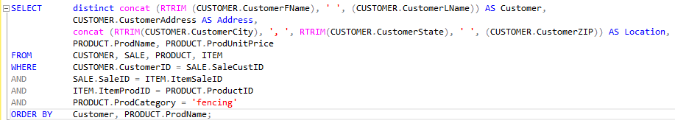

Solution:

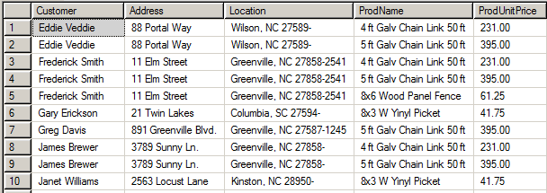

1. ENTER THE NUMBER OF ROWS RETURNED ABOVE: (2) ____39____
2. Create a correlated subquery to test if the customer’s address can be used as an alternate key. This can be done by testing for functional dependencies. (5)

Code:

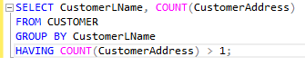

Solution:

*I don’t know how to do it the way you said, but this query tests whether anyone has more than one address. If they do, we can’t use address as the primary key.*



1. Can the address be used as an alternate key in #24 above? (MY ANSWER IS NO) (2)
2. The company is considering dropping all shed products. If they decided to liquidate all sheds at 20% off their regular price what would their potential profit be from the liquidation? (5)

Code:

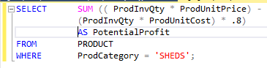

Solution:



1. What is the average value, highest value, and lowest value of all tools in inventory? (5)

Code:

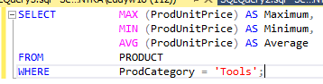

Solution:

